Solution to every third end-of-chapter problem
Basics of Engineering Economy, 2nd edition
Leland Blank and Anthony Tarquin

Chapter 6
Rate of Return Analysis

6.1 (a) The highest possible is infinity
(b) The lowest possible is -100%

6.4 In $ million units

Annual payment = 6,000,000(A/P,10%,10)
= 6,000,000(0.16275)
= $976,500

Principal remaining after year 1 = 6,000,000(1.10) – 976,500
= $5,623,500

Interest, year 2 = 5,623,500(0.10)
= $562,350

6.7 (a) Move all cash flows to year 1

0 = -80,000 + 9000(P/F,i*,1) + 70,000(P/F,i*,2) + 30,000(P/F,*i,3)

By trial and error, i* = 15.32%

(b) Enter cash flows for years 1 to 4 in cells B1:B4

Function = IRR(B1:B4) displays i* = 15.32%

6.10 (a) Tabulated factors

0 = -400,000(F/A,i*,10) + 270,000/i*

Try 5%: -400,000(12.5779) + 270,000/0.05 = $368,840 too low
Try 6%: -400,000(13.1808) + 270,000/0.06 = $-772,320 too high

Interpolation yields i* = 5.32%

(b) Solve for i* by spreadsheet using the FV function and GOAL SEEK. For
example, place a guess i* in cell B1and set up the single-cell function

= -FV($B$1,10,-400000) + 270000/$B$1
Display is i* = 5.29% per year

6.13 0 = -3,000,000 + 1,500,000(P/A,i*,3)
(P/A,i*,3) = 2.0000

Solve for i* = 23.38% per year (spreadsheet)

6.16 0 = -65,220(P/A,i*,4) + (57,925 – 35,220)(P/A,i*,31)(P/F,i*,4)
= -65,220(P/A,i*,4) + (22,705)(P/A,i*,31)(P/F,i*,4)

Solve by trial and error:

Try 6%: 0 = -225,994 + 250,510 = $24,516 i too low
Try 7%: 0 = -220,913 + 217,071 = $-3842 i too high

i* = 6.86% per year (interpolation or spreadsheet)

6.19 0 = 2,000,000 – 200,000(P/A,i*,2) – 2,200,000(P/F,i*,3)

Solve for i* = 10% per year (spreadsheet)

6.22 0 = -130,000 + (78,000 – 49,000)(P/A,i*,8) + 1000(P/G,i*,8) + 23,000(P/F,i*,8)

Solve for i* = 19.17 % (spreadsheet)

6.25 (a) The rate of return on the increment has to be larger than 18%
(b) The rate of return on the increment has to be smaller than 10%
(c) Two samples follow with approximate ROR values of 10% for X
and 18% for Y

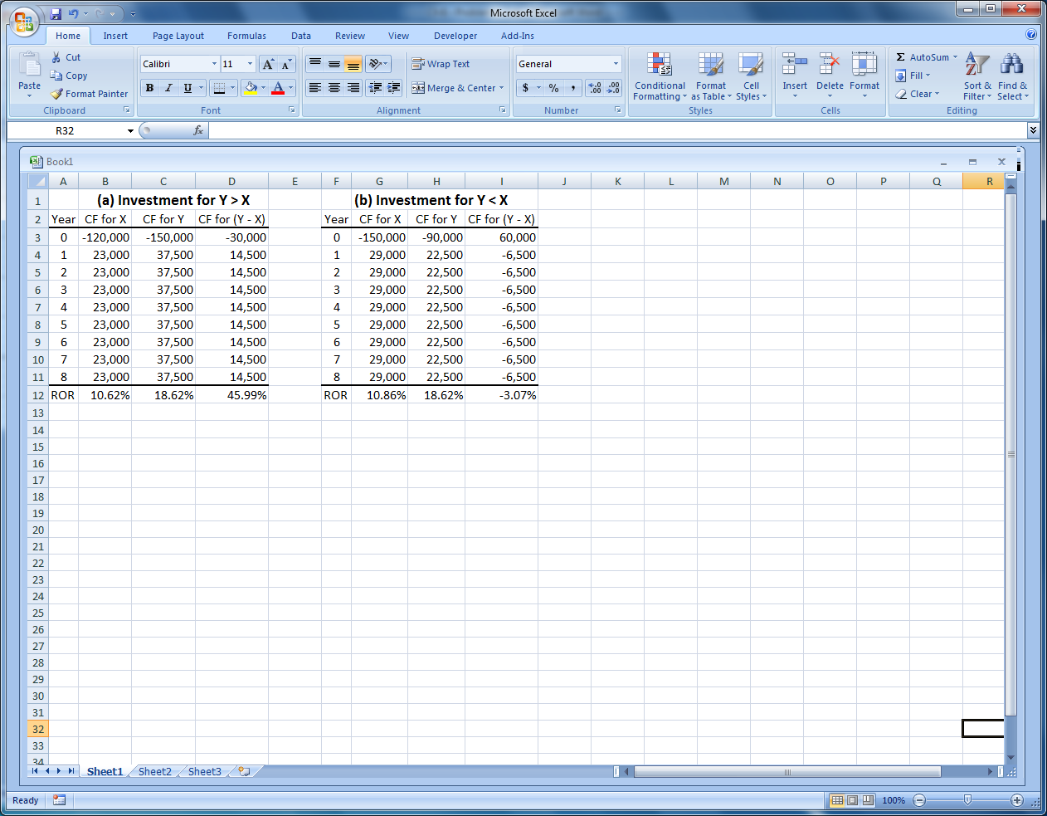

6.28 (a) Incremental CF, year 0: -25,000 –(-15,000) = $-10,000
(b) Incremental CF, year 3: -400 - (-1600 – 15,000 + 3000) = $+13,200
(c) Incremental CF, year 6: (-400+6000) – (-1600+3000) = $+4200

6.31 This is an incremental ROR analysis to find ∆i*

0 = -250,000(F/P,∆i*,8) + 50,000(F/A,∆i*,8) + 30,000

Solve for ∆i* = 13.14% < MARR = 15% (spreadsheet)

Select P

6.34 Incremental CF amounts for (Y-X)
Incremental first cost = $-62,000
Incremental M&O = $3,000
Incremental revenue = $23,000
Incremental salvage = $7,000

0 = -62,000 + 3,000(P/A,∆i*,3) + 23,000(P/A ∆i*,3) + 7000(P/F,∆i*,3)

Solve for ∆i* by trial and error or spreadsheet

∆i* = 16.83% > MARR = 15% (spreadsheet)

Select robot Y

6.37 Alternatives are independent; compare each against DN

Product 1: 0 = -340,000 + (180,000 – 70,000)(P/A,i*,5)
i* = 18.52% > MARR = 15% Accept

Product 2: 0 = -500,000 + (190,000 – 64,000)(P/A,i*,5)
i* = 8.23% < MARR = 15% Reject

Product 3: 0 = -570,000 + (220,000 –48,000)(P/A,i*,5)
i* = 15.49% > MARR = 15% Accept

Product 4: 0 = -620,000 + (205,000 – 40,000)(P/A,i*,5)
i* = 10.35% < MARR = 15% Reject
Company should manufacture product lines 1 and 3

6.40 Rank revenue alternatives by increasing initial investment: DN, D, A, B, E, C

(a) MARR = 13.5%
DN to D: ∆i* = 15% > MARR eliminate DN
A to D: ∆i* = 12% < MARR eliminate A
B to D: ∆i* = 26% > MARR eliminate D
E to B: ∆i* = -16% < MARR eliminate E
C to B: ∆i* = 25% > MARR eliminate B
Select C

(b) MARR = 16%
D to DN: ∆i* = 15% < MARR eliminate D
A to DN: ∆i* = 13% < MARR eliminate A
B to DN: ∆i* = 23% > MARR eliminate DN
E to B: ∆i* = -16% < MARR eliminate E
C to B: ∆i* = 25% > MARR eliminate B

Select C

6.43 (a) Select A and C with project ROR > MARR = 15.5%

(b) Rank proposals: DN, A, B, C, D; MARR = 10%
A to DN: ∆i* = 29% < MARR eliminate DN
B to A: ∆i* = 1% < MARR eliminate B
C to A: ∆i* = 7% < MARR eliminate C
D to A: ∆i* = 10% = MARR eliminate A Select D

(c) Same as part (b) above, except last comparison against MARR = 14%

D to A: ∆i* = 10% < MARR eliminate D Select A

6.46 (a) Two sign changes; maximum number of i* values is two

(b) Cumulative
Year Net Cash Flow, $ Cash Flow, $
0 -40,000 -40,000
1 32,000 -8000
2 18,000 +10,000
3 -2000 +8000
4 -1000 +7000

There is one sign change in the cumulative cash flow series; only one positive i*
value is indicated

6.49 Quarter Expenses Revenue Net Cash Flow Cumulative
0 -20 0 -20 -20
1 -20 5 -15 -35
2 -10 10 0 -35
3 -10 25 15 -20
4 -10 26 16 -4
5 -10 20 10 +6
6 -15 17 2 +8
7 -12 15 3 +11
8 -15 2 -13 -2

- From net cash flows, there are two possible i* values

- From cumulative cash flow, sign starts negative and changes twice. Norstrom’s criterion is not satisfied, there may be up to two i* values.

6.52 (a) 3 changes in sign of net cash flow; 3 possible i* values

(b) Cumulative
Year Net CF, $ CF, $
0 -17,000 -17,000
1 -20,000 -37,000
2 4,000 -33,000
3 -11,000 -44,000
4 32,000 -12,000
5 47,000 +35,000

Per Norstrom’s criterion, there is only one positive i* value

0 = -17 - 20(P/F,i*,1) + 4(P/F,i*,2) -11(P/F,i*,3) + 32(P/F,i*,4) + 47(P/F,i*,5)
i* = 17.39% (spreadsheet)

6.55 Tabulate net cash flow and cumulative cash flow values

Cumulative
Year Cash Flow, $ Cash Flow, $
0 0 0
1 -5000 -5,000
2 -5000 -10,000
3 -5000 -15,000
4 -5000 -20,000
5 -5000 -25,000
6 -5000 -30,000
7 +9000 -21,000
8 -5000 -26,000
9 -5000 -31,000
10 -5000 + 50,000 +14,000

(a) Cash flow rule of signs test (Descartes’ rule): three possible ROR values
Cumulative cash flow test (Norstrom’s criterion): one positive ROR value

(b) Move all cash flows to year 10 and solve for i*

0 = -5000(F/A,i*,10) + 14,000(F/P,i*,3) + 50,000

Solve for i* = 6.29% (spreadsheet)

(c) Hand solution: MIRR with i_{r} = 20% and i_{b} = 8%

PW₀ = -5000(P/A,i_{b},6) – 5000(P/A,i_{b},3)(P/F,i_{b},7)
= -5000(P/A,8%,6) – 5000(P/A,8%,3)(P/F,8%,7)
= -5000(4.6229) – 5000(2.5771)(0.5835)
= $-30,631

FW₁₀ = 9000(F/P,i_{r},3) + 50,000
= 9000(F/P,20%,3) + 50,000
= 9000(1.7280) + 50,000
= $65,552

Find ROR at which PW₀ is equivalent to FW₁₀
PW₀(F/P,i′,10) + FW₁₀ = 0
-30,631(1 + i′)¹⁰ + 65,552 = 0
(1 + i′)¹⁰ = 2.1400
i′ = 7.91%

Spreadsheet solution: Enter cash flows for years 0 through 10 into cells
B2 through B12, The function = MIRR(B1:B11,8%,20%) displays
i′ = 7.90%

(d) Hand solution: In applying the ROIC procedure, all F values are negative
except the last one. Therefore, i″ is used in all equations. The ROIC EROR
(i″) is the same as the internal ROR value (i*) of 6.29% per year.

Spreadsheet solution: Use Figure 6.7 as a model and apply GOAL SEEK to
obtain i″ = 6.29%

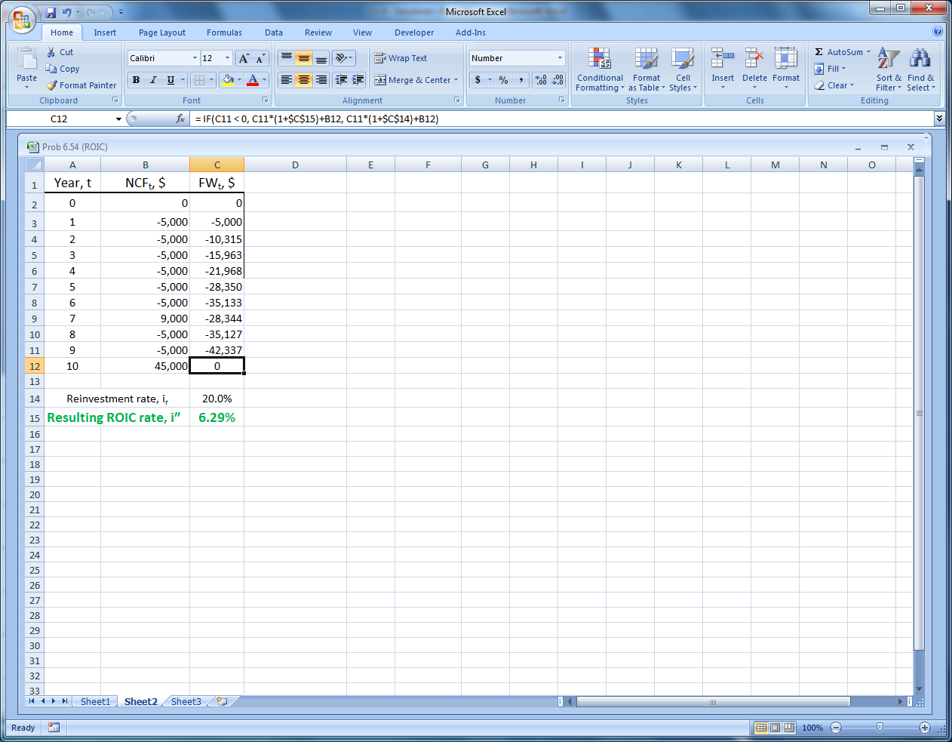

6.58 (a) Hand solution: ROIC procedure with i_{r} = 14%

F₀ = 5000 F₀ > 0; use i_{r}
F₁ = 5000(1.14) –2000 = 3700 F₁ > 0; use i_{r}
F₂ = 3700(1.14) –1500 = 2718 F₂ > 0; use i_{r}
F₃ = 2718(1.14) – 7000 = -3901.48 F₃ < 0; use i″
F₄ = -3901.48(1 + i″) + 4000

Set F₄ = 0 and solve for i″
i″ = 2.53%

Spreadsheet solution: ROIC with i_{r} = 14% results in i″ = 2.53%

Before GOAL SEEK After GOAL SEEK
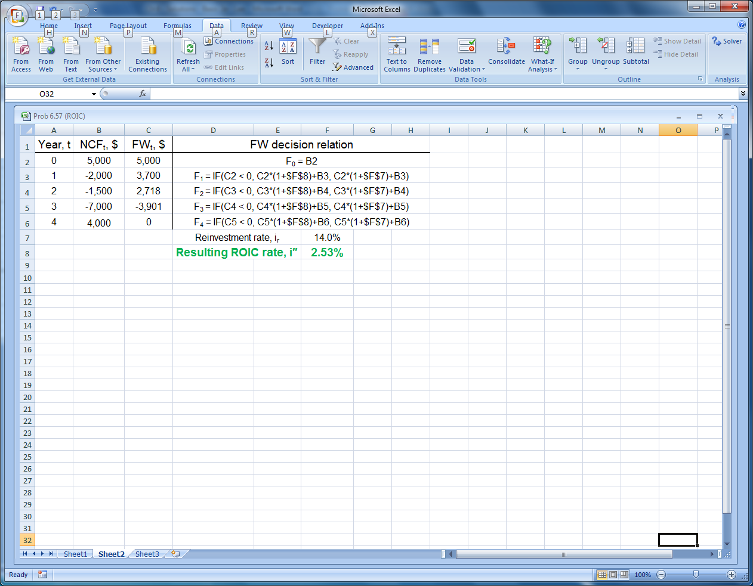
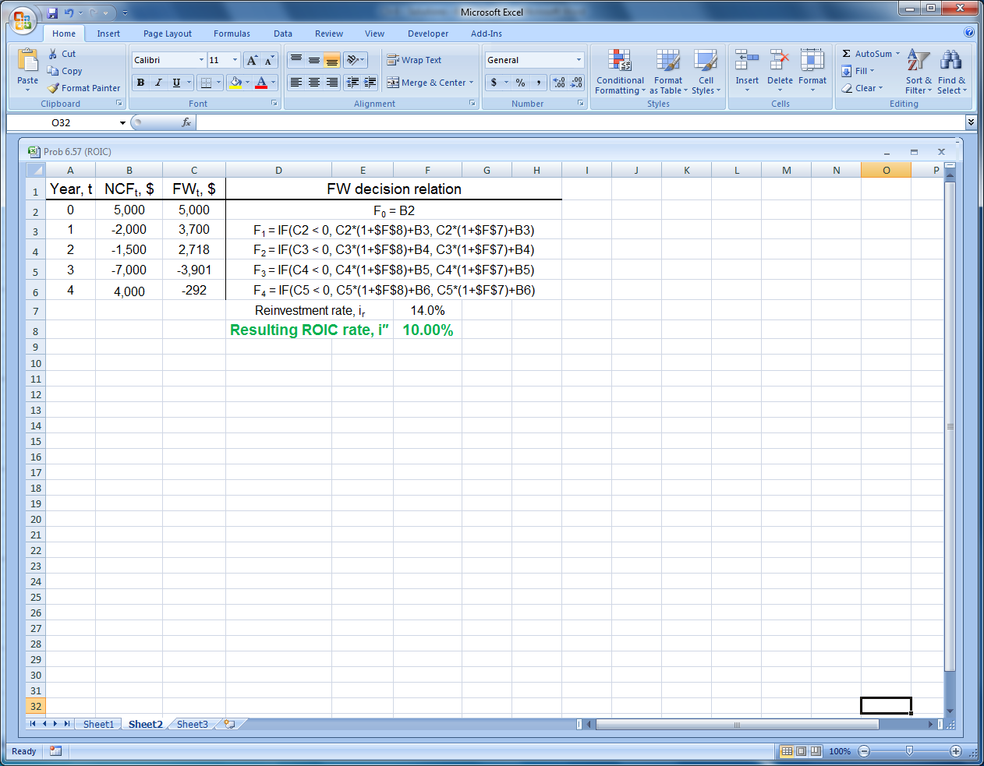

(b) Hand solution: Apply MIRR procedure with i_{b} = 7% and i_{r} = 14%

PW₀ = -2000(P/F,i_{b},1) – 1500(P/F,i_{b},2) - 7000(P/F,i_{b},3)
= -2000(P/F,7%,1) – 1500(P/F,7%,2) - 7000(P/F,7%,3)
= -2000(0.9346) – 1500(0.8734) – 7000(0.8163)
= $-8893

FW₄ = 5000(F/P,i_{r},4) + 4000
= 5000(F/P,14%,4) + 4000
= 5000(1.6890) + 4000
= $12,445

Find EROR at which PW₀ is equivalent to FW₄

PW₀(F/P,i′,4) + FW₄ = 0
-8893(1 + i′)⁴ + 12,445 = 0
(1 + i′)⁴ = 1.3994
i′ = 8.76%

Spreadsheet solution:

Enter cash flows in cells B2:B6 and apply function =MIRR(B2:B6,7%,14%) to
display i′ = 8.76%.
6.61 Answer is (b)

6.64 0 = -60,000 + 10,000(P/A,i*10)
(P/A,i*,10) = 6.0000

From tables, i* is between 10% and 11%

Answer is (a)

6.67 Answer is (c)

6.70 Answer is (c)

